Food Waste Policy

Our Food Waste

At [business name], we believe that reducing and redistributing our food waste is good for the wellbeing of our local community, our planet and our business.

[Business name] is a [restaurant/ café/ food retailer] located in [Cambridge/ other area]. We employ [number] staff and serve around [number] customers/ covers each [time period].

Food waste comes from the following sources:
- Spoilage: food that is damaged or out of date
- Preparation: food which is discarded during preparation or food which is prepared but not served
- Plate: food that is left on customers’ plates.

We are following WRAP’s food and drink waste hierarchy, shown below. We prioritise food waste prevention, redistribution and recycling over disposal.
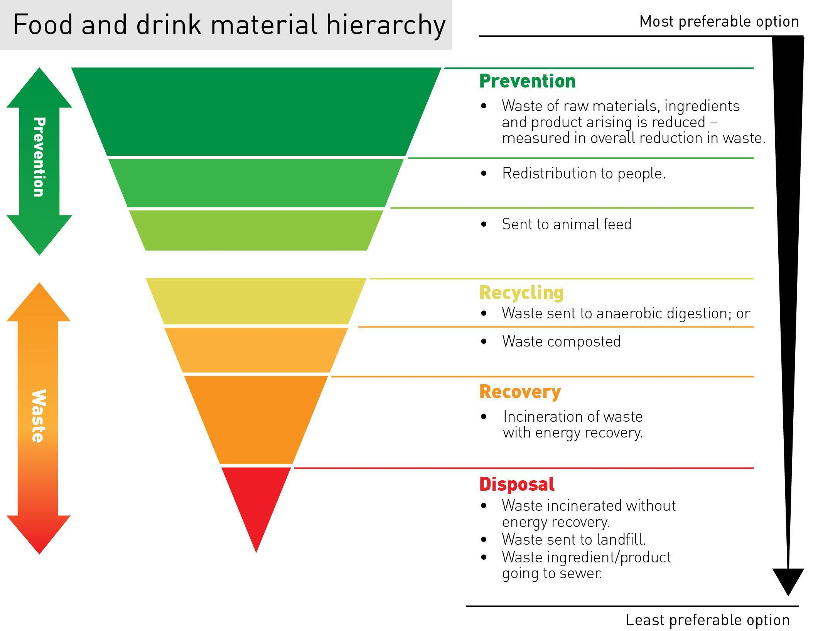

Our Targets

[Business name] is committed to the following targets:

- Reduce the amount of food we waste by [%] by [date]
- Redistribute surplus food which is still edible to [insert scheme name] from [date]
- Send food waste which cannot be redistributed for anaerobic digestion/ composting through [City Council/ other organisation] from [date]
- Ongoing compliance with relevant waste legislation.

Our Actions

In order to reach our targets we will:

- Elect a Food Waste Champion
- Develop and implement an action plan
- Communicate our policy, targets and action plan to our employees and customers
- Provide food waste reduction and recycling training for our staff
- Measure food waste from spoilage, preparation and diners’ plates on a [daily/ monthly/ quarterly] basis to track the impact of our actions
- Review and report our progress to Head Chefs and wider management on a [monthly/quarterly] basis
- Strive for continual improvement in food waste reduction and recycling.

Communication and Review

This policy is communicated to all staff and is available on our [website/ on request/ in our restaurant]. We will promote our successes to our staff and customers and report our progress to Cambridge Sustainable Food.

We will review and update this policy and associated targets annually.

Signed [by senior management]:

Name:

Position:

Date:

